

My Target: /25 or %

**Unit 2 Modern History**

**Score:**

/25

***Movements for change in the 20th century***

***SOURCE ANALYSIS ONE***

**Nazism in Germany 1918 - 1945**

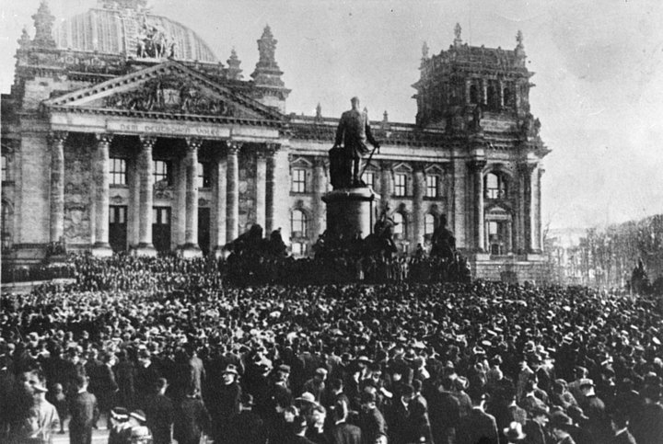

*Name: _______________________ Date:*

**Weighting - 10 %**

**Question 1**

Compare and contrast the messages in **Source 1** and **2**. *(4 marks)*

**Question 2**

**Evaluate** the usefulness**,** terms of strengths and weaknesses, of Sources 1 and 2 as representations of attitudes in post-war Germany.

*(5 marks)*

**Question 3**

**Explain** the historical context of **Source 3**. Include the relevant events, people and ideas depicted or represented in the source.  *(4 marks)*

**Question 4**

Identify and account for the authors’ perspectives in **Sources 3** and **4**, regarding the specific changes in post-war German politics described in the documents.

*(6 marks)*

**Question 5**

Evaluate the extent to which the **four** sources give an accurate insight into the significant changes occurring in post-war Germany between 1918 and 1922. *(6 marks)*

Spare Paper:

**END OF QUESTION BOOKLET**

**Source Booklet**

**Source 1:**

# 

***From the historian John Wheeler –Bennett on the origins of the ‘stab in the back’ legend:***

**One evening in the summer of 1919 while dining with the head of the British Military Mission, Major General Sir Neil Malcolm, Ludendorff was explaining how the Supreme Command had been ‘betrayed’ by the revolution on the home front. His style of speech was turgid and verbose and in an effort to clarify the meaning in a single sentence, General Malcolm asked ‘Do you mean General that you were stabbed in the back?’. Ludendorff’s eyes lit up and he leapt upon the phrase like a dog on a bone. ‘Stabbed in the back’, he repeated. ‘Yes that is it exactly. We were stabbed in the back’.**

R. Pares & A. J. P. Taylor, *Essays presented to Sir Lewis Namier,* Macmillan, London, 1956, p. 535

**Source 2:**

[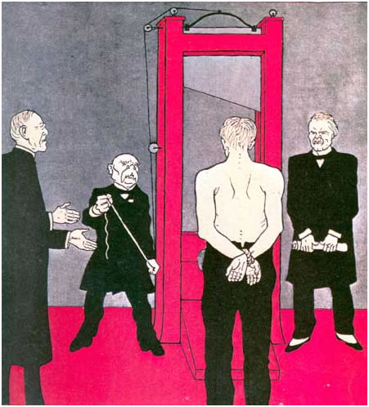](http://www.google.com.au/url?sa=i&rct=j&q=treaty+of+versailles+cartoon&source=images&cd=&cad=rja&uact=8&docid=zVx-1PypBf5L3M&tbnid=FFpGyt_KPKOw-M:&ved=0CAUQjRw&url=http://urbachc.org/urb-versailles-political-cartoons.html&ei=hEjPU8zfIMy68gXE4YKACQ&bvm=bv.71667212,d.dGc&psig=AFQjCNHNdIyK6WuNUW9IVP_AKonNBNwVQA&ust=1406179805177865)

**Source 3:**

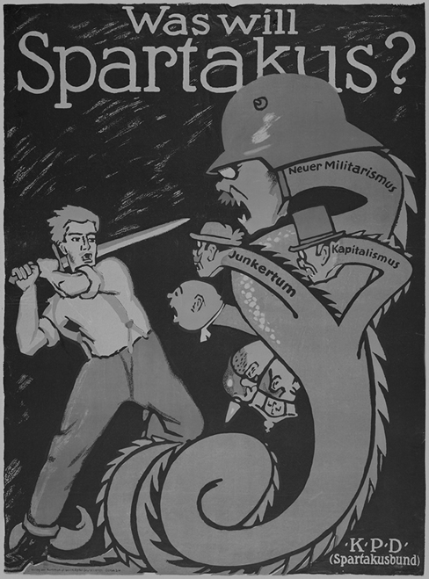

A poster made by the Spartacists, entitled ‘What does Spartacus want?’. The translations are:

Neuer Militarismus: Militarism

Kapitalismus: Capitalism

Junkertum: Landowners

**Source 4:**

**“The constitution which emerged from the Assembly after six months of debate was, on paper, the most liberal and democratic document of its kind that the twentieth century had seen, mechanically well-nigh perfect, full of ingenious and admirable devices which seemed to guarantee the working of an almost flawless democracy.”**

William Shirer, *The Rise and Fall of the Third Reich*, 2011